【Levi's CMS】CMS SI Project Q&A(20191018)

【Q&A】
Q1: Pixel Resolution
We got the screen size from email attachment.
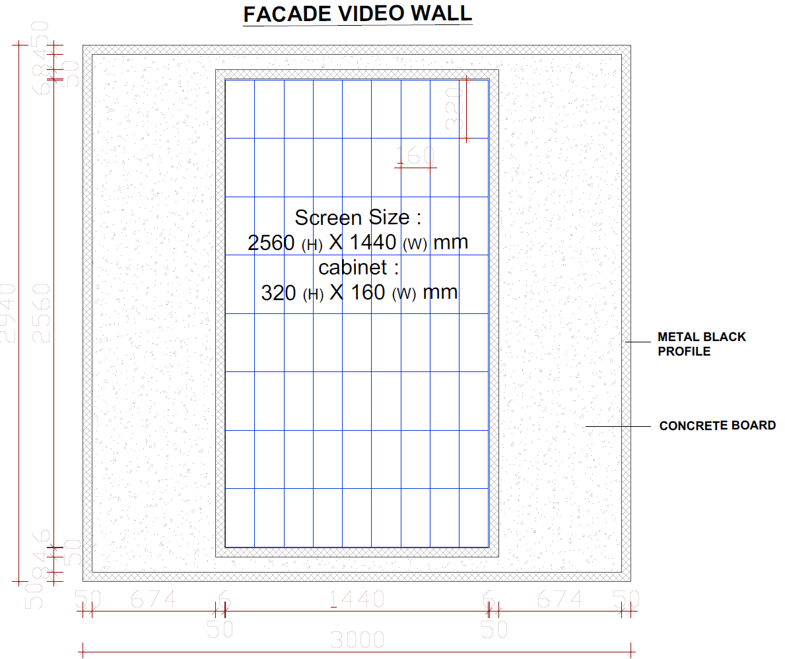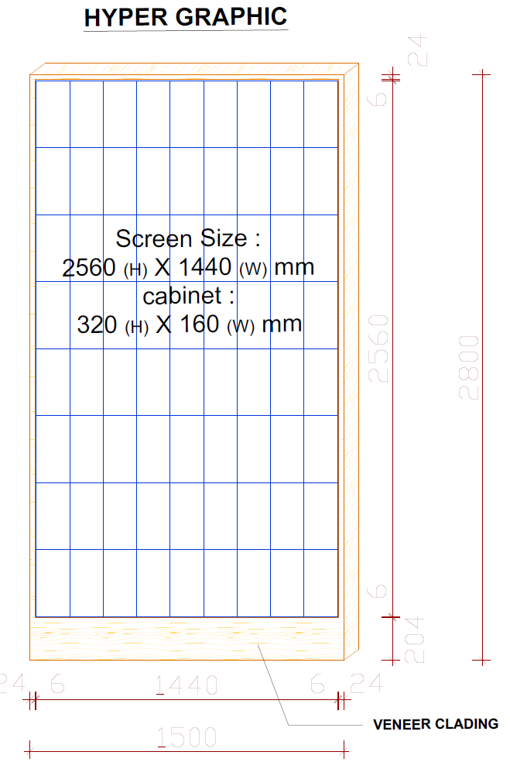
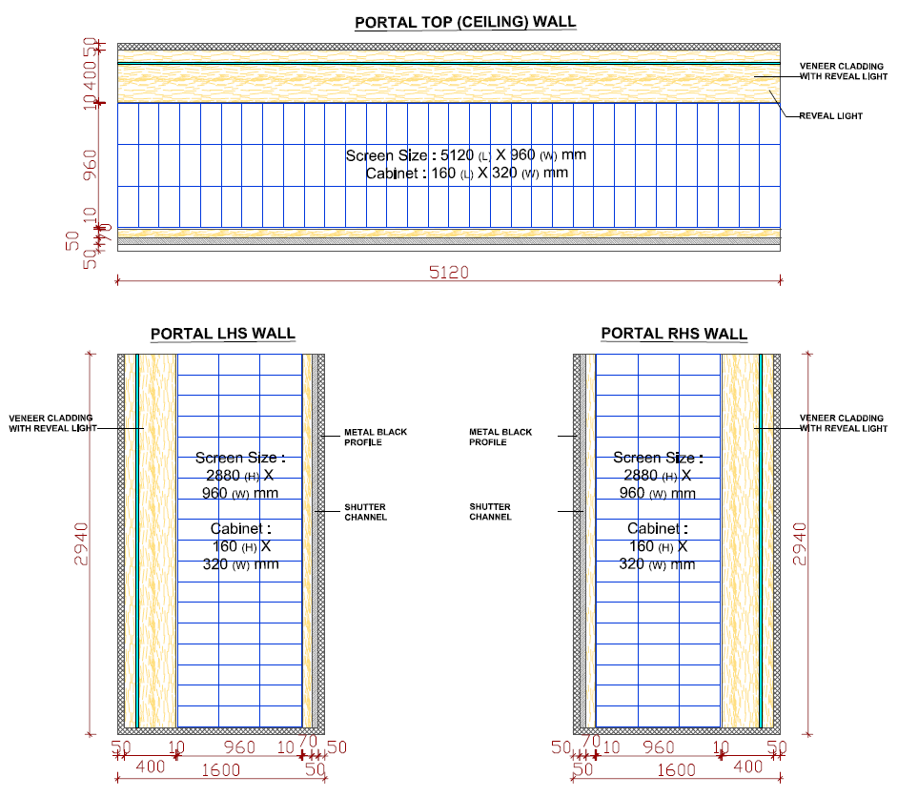

Our media box has a display limit. The pixel resolution limit what one media box can support is 1920px * 1080px.
So, please give us the pixel resolution of every screen.

Q2: Equipment Installation Environment
- The appearance size of the media box is 148mm * 114mm * 34mm. You need to make sure that you have enough space for the media boxes.

- Our display software what support by our media box is a SaaS service by internet. The placement of the media box need reserves a network cable socket and a power socket.

- The network cables need CAT6 standard. Includes the jumper cables and the in-wall cables.

- You need make sure whether the three portal walls need to be synchronized. If need we will add the router device in the equipment list

- IF the following screen’s pixel resolution exceeds 1920px * 1080px, then we will provide two media boxes for this screen. And LED vender need to provide video splicing equipment (“two in” – “one out” or “two out”).

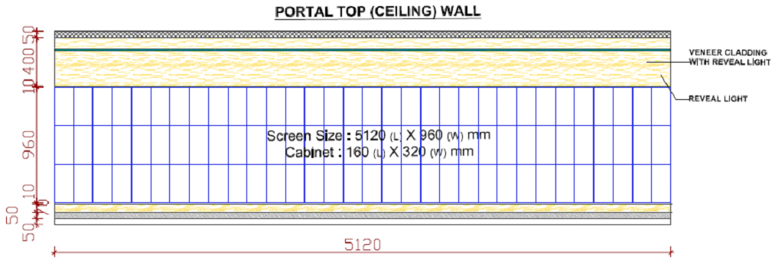

- Please check whether the store network can connect to the reverse SaaS service.
You can refer to the following documents: [V8 STB Standard Installation Requirements 2019-Network Check Manual (EN).docx]. Please reply the test result images to us.

CONFIRMER：Benjamin.Guo

DATE：2019-10-18

